|  |  |  |  |  |
| --- | --- | --- | --- | --- |
|  | Available online at www.sciencedirect.com | |  | |
|  | |
| AASRI Procedia 3 ( 2012 ) 474 – 480 | |
| 2012AASR RIConferen ceonModel ing,Identifi cationandC Control | | | | |
| Develop pment of f Omni D Direction nal Mobi ile Robo ot Navig | | | | ation |
| System m using | | RFID fo or Multi ple Obje ect | | |
| M.M. Ras shida,1,Nor r SaidahbtM MohdZainb b.2,Faridatu unbinti Moh hammad Z | | | | ainc,3 |
| *1,2, ,3Department of of Mechatronics s Engineering, I International Is slamic Universi ity Malaysia*  *Gombak, Ku uala Lumpur.am mahbub@iium.e edu.my* | | | | |

**Abst tract**

|  |  |  |  |  |
| --- | --- | --- | --- | --- |
| Navi igation is an im mportant techniq que in the field d of mobile rob otics. A major | | field of mobile e robot system | | is required to |
| navig gate in unknow wn environment ts accurately. B By determining | the positions a and selecting a | | motion control l of the robot, | |
| navig gation is fulfille ed through som me technique. In n this paper, a m modular naviga ation technique | | | in relation wit th signal from | |
| RFID D tags, and RFI ID reader is de veloped. The m main idea is to | test the ability | of mobile robo ot to navigate th he location in | | |
| indoo or environment ts. The RFID re eader is mounte ed on the mobi le robot to com mmunicate with h the RFID tags s to determine  robot t’s position whi ile the RFID tag gs is are placed d at difference lo ocation . The p osition of mobi ile robot is dete ermined based | | | | |
| on th he location of R RFID tag. The a actuator will be e move accordin ng to the angle | | between the ro obot’s current p positioned and | | |

the ta arget tag.

|  |  |  |  |  |  |  |  |
| --- | --- | --- | --- | --- | --- | --- | --- |
| © 2012 The Authors. Published by Elsevier B.V. © 20 012 Published d by Elsevier B B.V. Open access under [CC BY-NC-ND license.](http://creativecommons.org/licenses/by-nc-nd/3.0/)  Selection and/or peer review under responsibility of American Applied Science Research Institute Sele ection and/or p peer review un nder responsib bility of Amer rican Applied Science Rese earch Institute  *Keyw words: Omni robo ot; Robot navigati ion; Reader; tran nsponder* | | | | | | | |
| **1. In ntroduction** | | | | | | | |
| Mobile robot | navigation sy ystem has be ecome an app pealing challe enge in both | | | | | research and d production | |
| indu ustry. It is imp portant due to its ability to | | navigate the | location in un nknown enviro onment. Navi igation is the | | | | |
| abili ity of a robot t to determine e its own pos sition in its fr frame of refer rence and the n find its targ get location. | | | | | | | |
| Nav igation can b e divided into o three main | | fundamental | | which are se elf-localization n, path planni ing and map | | | |
| build ding.Self-loca alization mean ns robot’s abil lity to establis sh its own po osition and ori ientation with hin the frame | | | | | | | |
| of re eference. Path h planning is e effectively an n extension of f localization, | | | | | in that it requ uires the dete | | rmination of |
| the r robot's current t position and a position of a goal locatio on while map b building can b be any notatio on describing  locat tions in the ro obot frame of r reference. | | | | | | | |
| The aim of th his project is t to develop Om mni Directiona al Robot Navi igation system m using RFID | | | | | | | for multiple |

2212-6716 © 2012 The Authors. Published by Elsevier B.V. Open access under [CC BY-NC-ND license.](http://creativecommons.org/licenses/by-nc-nd/3.0/)

Selection and/or peer review under responsibility of American Applied Science Research Institute

doi: 10.1016/j.aasri.2012.11.075

*M.M. Rashid et al. / AASRI Procedia 3 ( 2012 ) 474 – 480*  475

destinations. Both Omni robot and RFID system must be integrated to each other in the way of controlling the whole system. Omni robot is concerned due to its capability of mechanical manipulator and is capable of tethered and autonomous operation. It also focuses on RFID system which relies on navigation module using customized features of RFID technology. RFID system consists of tags, reader with antenna, and software. When an RFID reader scans the tag, a pulse of radio energy is sent out and the tag sends back the inventory control number.

The objectives of this paper are;

 To design and develop Omni directional mobile robot that can move in indoor environment.

 To perform navigation by allocating identification tag at certain located area.

 To develop an efficient algorithm in providing better solution during navigation and to go particular target.

**2. Methodology**

Following is the desired algorithm of mobile robot navigation system to navigate desired location of RFID tag by identifying the angle between the tags and the reader which is mounted on the mobile robot.Navigation elaborates the desired algorithm of mobile robot navigation system to navigate location of RFID tag by identifying the angle between the tags and the reader which is mounted on the mobile robot.

Initially, the robot is pre-programmed with an order list of tag numbers in defining the position of the tag whereas the current target angle is determined by calculating current goal location. When the known ID is achieved, the target transponder is detected through the signal backscattered from all the tags within the communication range. The calculation after input received by the two antennas is recorded and computed using;

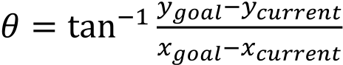 *(1)*

The mobile robot is then updating its headed by turn right and left and checked whether the angle between calculated and compass is reached. If not, it will turn until it found the correct angle. If yes, mobile robot is moving forward and detected more points. Mobile robot is then identifying current tag whether it is goal or not. If goal, it will stop. If not it will calculate current to goal angle and compare through continuous loop until it find the goal.

**3. Omni Robot**   
 The Omni directional mechanismhave three axis and angle (x,y, ) movement abruptly in a two dimensional space, which ease to increase robot mobility and more keen access to limited spaces compared withconventional two wheel driven robot [1]. Yukawa et al. further explained that Omni-directional mechanism in the robot consists of four wheel units with a driving mechanism and a steering wheel mechanism. Since the four wheel units drive and steer independently, the position and direction of the mobile robot can be controlled with a high degree of accuracy [2]. Omni robot is becoming technically demanding for users in industrial and business sectors Figure 1. Many Omni robot navigation system products are appearing within medium and long term propositions that lead to development of variety technology advancement in the future. The most common and popular navigation techniques suggested in the state of the art generally fall under one of the following categories: dead-reckoning based, landmark-based, vision based, and behaviour technique based [3].

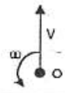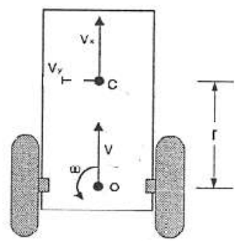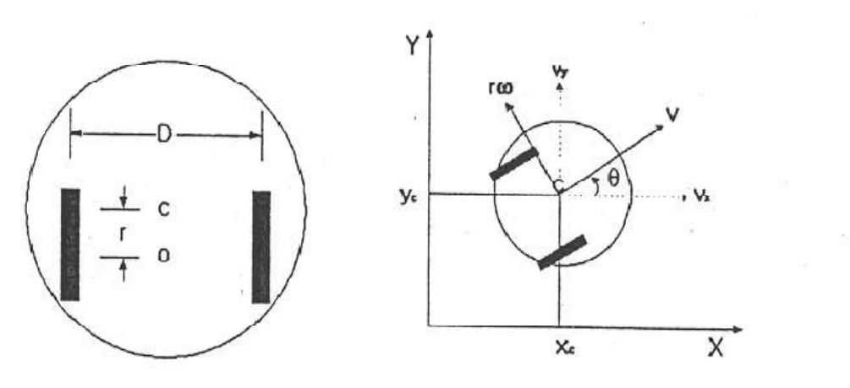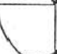

|  |  |
| --- | --- |
| 476 | *M.M. Rashid et al. / AASRI Procedia 3 ( 2012 ) 474 – 480* |

Figure 1: Two wheel mobile robot

**A.Navigation**

The fundamental requirement for mobile robot through navigation is to estimate the position of the autonomous mobile robot. In earlier research, there are several methods used to estimating the robot position for example path planning, trajectory planning, algorithmic exploration and path execution with self-localization. The goal of autonomous robot navigation is built for a system in which dynamically guide and control the mobile robot from its start positions to a predefined end position. According to the previous research, it is state that the robot successfully done their task if the robot can efficiently interpret the data from the sensor [4]. The first method used in previous research is self-localization. This method used the passive RFID tag where placed on the floor. The advantages of this method is that there does not required any information regarding the RFID tag except their ID number. Besides that, this method is used without need for the robot to stop temporarily to observe the RFID tag [5].

In addition, it is required to calculate the distance between the robot and the wall at the time robot passes the specific area to smoothly organize the movement of the robot. Other than that, by using the trajectory planning and path planning, we can estimate the position of the mobile robot. The differences between this method is that the presence of moving and avoiding the obstacle. The path planning used common approach by performing the specific algorithm to determine the shortest path. While for the trajectory planning in the presence of obstacle and find out the path and motion along the path. Furthermore, effective approach can be used by combining the dead reckoning and external sensing by using the metric model. By using the odometry, the approximate current pose can be obtaining but maintain the pose estimate [4].

Figure 2: Active–Driving Wheel in Two Dimensions

**B.Two wheel mobile robot**   
 Omni Directional robot locality is identical by 3-coordinates: position (x, y) and robot direction angle in an absolute frame. Therobot can mimic the waywhich [5-8] acquired from the current posture (x, y, ) in analignment space. Figure 2 shows an active driving two-wheeled robotwhereC is the centre ofmotion of the robot. The platformscentre of gravity of is at the origin (o), and (Vx, Vy)represents linear speed or tangential velocity, and w is the angular velocity. Here,*r* is the radius of the wheels, and *D* for azimuth length between the wheels [9]. Robot linear speed is defined by the absolute velocity (Vx, Vy) (Cartesian)in the platform

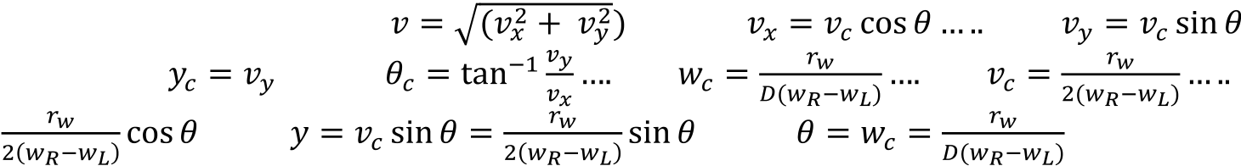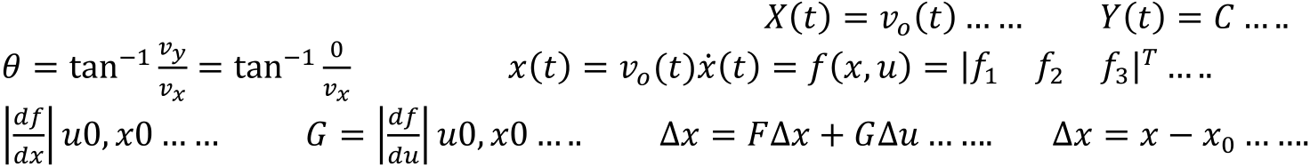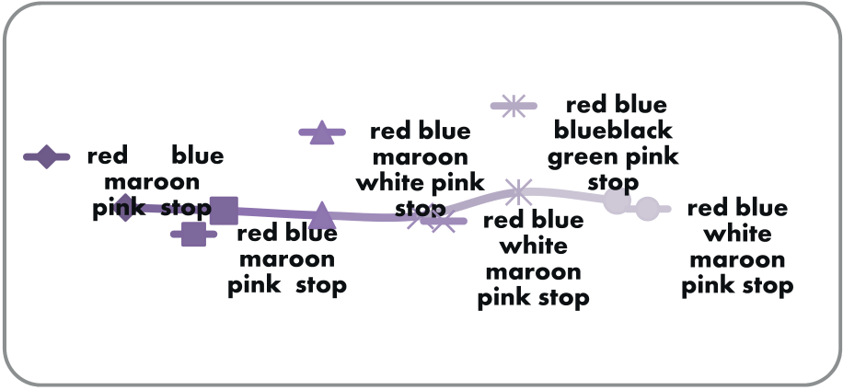

*M.M. Rashid et al. / AASRI Procedia 3 ( 2012 ) 474 – 480*  477

coordinate system at the origin (o), and w for the angular velocity [9-11]. Theta ( ) denotesthe heading angle

of the turn in radians. The system is represented in (x, y) coordinate (and orientation) varying with respect to

time. At any instant, the x the y coordinates of the robot’s centre point are changing based on its speed and

orientation. While the time varying states, the physical laws governs the behaviour of the mobile robot but the

system is time invariant. ….(1), (2), …..(3), 

(4) ….(5), (6), (7), (8), 

…..(9) ….(10) …..(11)

Where:= right wheel angular velocity, = left wheel angular velocity,*D* = azimuth distance between the

wheels, = wheel radius, = tangential velocity, or linear velocity, and = angular velocity, or steering

velocity of the robot. The control inputs = (, ) and our control outputs = (*X, Y, ).* Therefore, desired

trajectory is X (t), Y (t), (t).However, it is difficult to study 3rd order and nonlinearsystem. Some nonlinear

equations can be approximated by linear equations under certain conditions. Most of the system behaves like

a linear system has a trajectory called the nominal trajectory. In this case chosen conditions for the system

|  |  |  |  |  |  |
| --- | --- | --- | --- | --- | --- |
| behaviour and modelled a linear system are followed. | | | (12), | (13) |  |
| …….(14), | | | | (15), |
| (16), | | (17), | (18) | (19) |
|  | ………(20) | | | (22) |
|  | | ……….(21) | |
| Both wheels have the same initial speed. | | | |

**4 Result**

Data from in table 1 are collected to check whether the tag is detected fast or not. This experiment is

aimed to verify the counting number of passive tag that can be detected in 5.3 sec at a distance of 1cm.This

passive tag can be detected at the range of 150mm.Each trial is tested to check detected tag during navigation.

Each trial in figure 4 summarizes the path taken by mobile robot to reach its target.For trial 1 and 2, only five

tag is detected, while trial 3, 4, and 6, six tag is detected and both trial 4 and 5, seven tag is detected. This

experiment results in random decision path which will be taken by each trial.

Table 1: Numbers of ID tag detect in 5.3 sec

**Trial vs Tag Detected**

Figure 3: ID detection for each trial

|  |  |  |
| --- | --- | --- |
| Trial | Tag Detected(name) | Count |
| 1 | Red | 93 |
| 2 | Stop | 79 |
| 3 | Blue | 82 |
| 4 | Blue black | 84 |
| 5 | Dark blue | 88 |

Several trials as shown in table 2 have been conducted to evaluate time elapse for the mobile robot to reach the goal from the starting point. Each of tag has been named accordingly based on the ID tag positions.

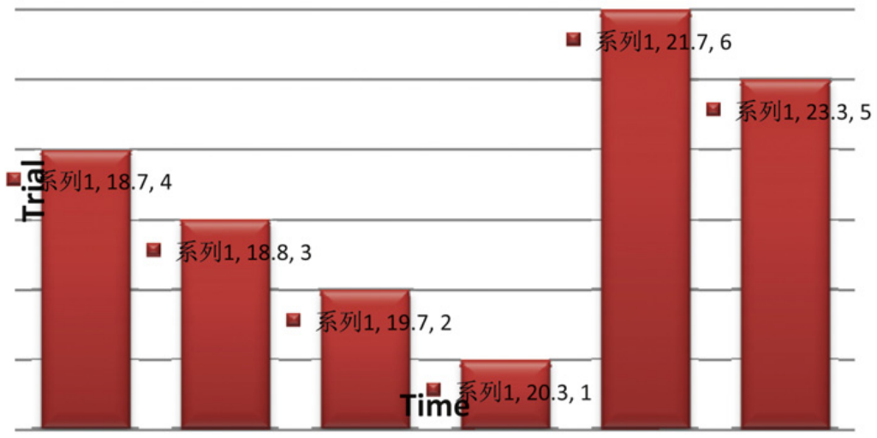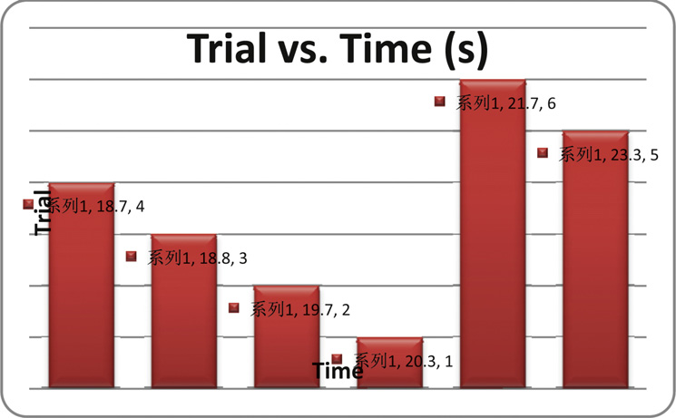

478  *M.M. Rashid et al. / AASRI Procedia 3 ( 2012 ) 474 – 480*

Acco ording to figu ure 5, mobile robot naviga ation is alway ys updating its s angle until it finds the g oal. Current

head ding can be ca alculated using g;

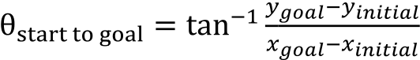…..(23) ,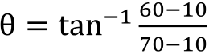………(24), … (25)

To g get exact rotati ion of mobile robot;

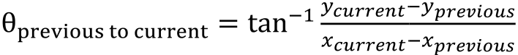……….(26) 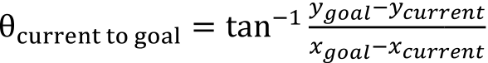 (27)

…….(28)

Figur re 4: Time elapse to reach goal pos sition

**a)**  **Testing and Evaluation**

To verify wh hether the mo obile robot ism moving accor rdingly and ac chieved the o objectives, sev veral testing

need d to be consid dered literally y. At first, pro ogramming in nstruction is u uploaded to th he microcontro oller to turn

right t if compass angle is grea ater than head ding, turn left t if compass angle is less than heading g, and move

forw ward when com mpass angle is s equal to head ding angle. Ho owever, the ro obot doesn’t m move accordin ngly because

the p probability for r the robot to m move forward d by ±1 is imp possible. Then n, the instructio on is adjusted d by ±3.

The results do oes not accura ately headed t the mobile rob bot to the goa al, but in ideal l condition the e calculation

has p proved that ev verything sho uld be in the right track if the procedure es is follow ac ccordingly. Th his might be

due to late reactio on of RFID an ntenna to read the tag at time e it reached ta ag. Moreover, the programm ming is quite

long g and thus cau ses delay for l looping. Durin ng the process s, the antenna could not rea ad tag accordin ngly when it

head ded to the tag g, instead the e antenna coi ls must be at t the centre o of the tag so that it can r read the tag

simu ultaneously. S Some reading g is missed du uring navigat tion process a as this proble em occurs. Th his problem

happ pens due to le ess read rang e of the read er. Mobile ro obot somehow w didn’t move e to the centr re of the tag

altho ough it reache ed the tag poi nt. Trials sho w that possib bility to reduce e error is whe en the displac ement taken

by th he mobile rob ot is closed to o the ideal disp placement.

**5. C onclusion**

Basic develop pment of this robot has bee en constructed d and tested. G Generally, the objectives of f this project

have e been met sin nce the aims a are to develop p and design th he Omni mob bile robot used d for navigatio on in indoor

envi ironment. The e result show s that the pro ototype mode el of mobile r robot with RF FID system is s able to be

*M.M. Rashid et al. / AASRI Procedia 3 ( 2012 ) 474 – 480*  479

applied in real situation. In addition, the position of the mobile robot is determined based on information provided by the tag and the orientation information by the compass while the angle between the robot’s current direction and the target tag is used to provide action to the actuators.Intelligent controller might be applied to the system to reduce an error. Moreover, suitable sensor such as ultrasonic sensor might be used to avoid obstacles in indoor environment.

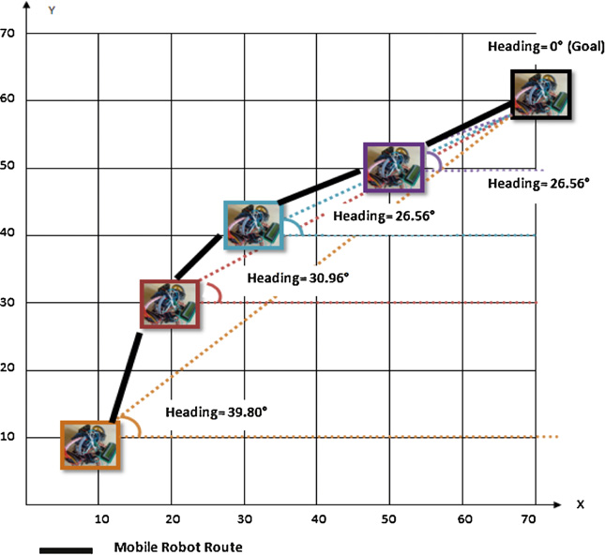

Figure 5: Navigation path

**References**   
[1]San, K. and Dong H. K., (2007). *A design and implementation of moving object tracking system for omni-directional robot*, International Conference on Control, Automation and Systems 2007 Oct. 17-20, 2007 in COEX, Seoul, Korea, 1790-1793.

[2]Yukawa, T., Matsumoto, T., Okano, H., & Hosoya, O. (2006). *Development of an omni-directional mobile robot with two or more cameras and navigation based on cell map information*, 32nd Annual Conference onIEEE Industrial Electronics, IECON 2006, 213-218.

[3]Miah, M.S., & Gueaib, W. (2007). *An RFID-Based Robot Navigation System with a Customized RFID Tag Architecture*, 18, 25-30.

[4]Feng Lu (2004), *Shape Registration using optimization for mobile robot navigation*, 1-153.

[5]Kimuro, Y., Takarabe, S., & Hasegawa, T.(2007). *Machine Learning Approach to Self-Localization of Mobile Robot using RFID Tag*,Advanced intelligent mechatronics, 2007 IEEE/ASME international conference,1-6.

[6]Martinussen, E. S., and Arnall, T. (2009). *Designing with RFID*, Proceedings of the Third International Conference on Tangible and Embedded Interaction (TEI'09), Feb 16-18 2009, Cambridge, UK, 343-350. [7]Miah, M.S., & Gueaib, W. (2007), *Intelligent Parallel Parking of a Car- Like Mobile Road Using RFID Technology*, International Workshop on Robotic and Sensors Environments, 1-6.

[8]Hae, D.C., Sibum, J., Heejae, J., & Sang, W. A. (2004). Using RFID for Accurate Positioning:*Journal of Global Positioning System*s, 3, 32-39.

[9]Nuha.N (2005), *H-Infinity Control Of An Autonomous Mobile Robot*, 1-85.

[10]Finkenzeller.K (2003), RFID Handbook: *Fundamentals and Applications in Contactless Smart Cards and Identification*(2nd Ed.),Germany, John Wiley & Sons Ltd.

480  *M.M. Rashid et al. / AASRI Procedia 3 ( 2012 ) 474 – 480*

[11]Heesung Chae & Sangik Na (2007). *Mobile Robot Navigation using RFID and Vision Sensor.* 2007

International Symposium on Information Technology Convergence, 52-57.